3GPP TSG RAN WG1 #125 R1-2604133
Dalian, China, May 18th ~ 22nd, 2026

Source: OPPO
Title: Discussion on sensing detection and integration with communication
Agenda Item: 10.8.2
Document for: Discussion and Decision

Introduction
In RAN1#124bis meeting, the following agreements were made for this agenda [1].
Agreement:
- On RS for ISAC, study at least the following aspects, considering sensing performance, resource overhead and impact to communication
  - RS for communication is reused for sensing
  - Enhanced RS for sensing, taking reuse of RS for communication as starting point
    - Note: Part of or all of the RS may be used for communication purpose, and it does not mean the final decision on whether the enhanced RS is used for communication purpose is to be made in this agenda.
  - Dedicated RS for sensing
Agreement:
- Study RE patterns of RS for sensing, considering sensing performance, resource overhead and impact to communication
- Note: enhancements on RS sequence if any will be discussed in agenda 10.8.3
Agreement:
- On measurement for ISAC, study at least the following aspects.
  - Measurement definitions/levels for TRP-side measurement, taking the measurement Levels studied in NR ISAC as starting point
  - Measurement definitions/levels for UE-side measurement
  - Impacts of non-ideal factors on measurement
  - Other aspects are not precluded
  - Note: this discussion may or may not mean there is specification impact
Agreement:
- On measurement report for ISAC, study at least the following aspects and applicable scenarios (e.g., sensing modes, targets, etc.) from RAN1 perspective.
  - Measurement reporting mechanism from UE
    - Option 1A: The UE measurements and/or assistance information if needed from UE can be directly sent to aNB
    - Option 1B: The UE measurements and/or assistance information if needed from UE can be sent to SF
  - Measurement reporting mechanism from aNB
    - Option 2A: The aNB measurements and/or assistance information if needed from aNB can be directly sent to UE
    - Option 2B: The aNB measurements and/or assistance information if needed from aNB can be sent to SF
  - The study may require cross-WG coordination.
  - Note: combination of multiple options is not precluded.
- Note: measurements in each option may be different

Agreement:
- On measurement report for ISAC, study impacts from at least the following aspects from RAN1 perspective
  - Measurement reporting mechanism
    - E.g., Periodic, semi-persistent, aperiodic, event-triggered report as starting point
    - Reporting signaling e.g., L1, L2, higher layer, etc.
  - Other aspects are not precluded
  - The study may require cross-WG coordination.

This contribution gives our initial views on the sensing detection algorithm and the interaction between sensing and communication in 6GR, assuming OFDM waveform with normal CP length.

The considerations on 6G sensing procedure
In order to have a clear fresh discussion for 6G ISAC in RAN1 and meanwhile maintain a smooth inheritance from 5G ISAC, it is suggested to keep using key terminologies or abbreviations from 5G for entities appearing in a sensing procedure, such as STX, SRX, ST and SenF (which was used in SA for sensing function node).
Proposal 1: Adopt following terminologies/abbreviations for sensing entities in RAN1 discussion of 6G ISAC.
- STX: Sensing transmitter.
- SRX: Sensing receiver.
- ST: Sensing target.
- SenF: Sensing function node on network side.
Although 5G-ISAC evaluation prioritized FR1, it was agreed in RAN #111 to “preserve FR2 extensibility wherever feasible”. In our view, the 6G ISAC study should not preclude any frequency range, unless it is found in a later stage of the study that supporting a particular frequency range meets with tremendous technical difficulty.
Proposal 2: RAN1 study of 6G ISAC in AI 10.8.2 does not assume a preclusion of any frequency range.

Sensing detection and corresponding requirements on sensing reference signal
Based on the channel impulse response defined in TR38.901, a sensing signal received at a SRX antenna element $u$ is given in (1).
$r_{u}\left(t,τ\right)=\sum_{p,s}{α_{p}∙\exp\left(j2π\frac{d_{p,u,s}}{λ_{0}}\right)∙\exp\left(j2π\int_{t_{0}}^{t}{f_{p}\left(\tilde{t}\right)d\tilde{t}}\right)∙s\left(t,τ-τ_{p}\right)}+n\left(t,τ\right)$ (1)
where
- $t$ is the time-domain that is referred as slow-time in radar theory, and $τ$ is the delay-domain referred as fast-time.
- {$p$} is a set of multipath including those from target channels and those from background channel. Here a path p may correspond to a single end-to-end ray under convolution concatenation in the target channel, i.e., a single combination of $〈n,m;n^{'},m^{'}〉$ in section 7.9.4.1 of TR38.901. The large-scale pathloss, target RCS gain, CPM gain and antenna field gain are all merged into $α_{p}$.
- {$s$} is the set of STX antenna elements, from which the sensing signal $s\left(t,τ\right)$ is transmitted.
The received signal in (1) provides nothing but four aspects for the sensing detection: $f_{p}\left(\tilde{t}\right)$ for Doppler, $τ_{p}$ for delay, $d_{p,u,s}$ for angle or direction relative to antenna element panel and $α_{p}$ for aggregated amplitude/power. In 5GA-ISAC, $α_{p}$ contributes to a confidence metric but not a measurement directly used in a sensing detection. We believe that the object detection and tracking in 6GR should continue to focus on Doppler/delay/angle or their equivalences.
Proposal 3: The 6GR study of object detection and tracking should focus on the detection of Doppler/delay/angle or their equivalences.
Detection of Doppler
Doppler detection is performed upon $\exp\left(j2π\int_{t_{0}}^{t}{f_{p}\left(\tilde{t}\right)d\tilde{t}}\right)$ in (1). One technical issue in the Doppler detection is the Doppler ambiguity.
In a symbol-based system, $t=m∙T_{sym}$ is applied to (1), where $m$ is the symbol index in a coherent processing interval (CPI) and $T_{sym}$ is the symbol duration. Assume an ideal case where each multipath can be separated from each other at the SRX and the Doppler terms $f_{p}\left(\tilde{t}\right)$ are independent from each other over different $p$. For a macro-Doppler detection where $f_{p}\left(\tilde{t}\right)=f_{p}$, the outputs from a receiver match filter (matching to signal $s\left(m,τ\right)$) are
$$y_{u,p}\left(m\right)=α_{p}^{'}∙\exp\left(j2π\int_{t_{0}}^{m∙T_{sym}}{f_{p}d\tilde{t}}\right)+n\left(m\right)$$
and theoretically the macro-Doppler $f_{p}$ can be optimally derived as following, where $p\left(y_{u,p}\left(m\right) for all m | f_{p}\right)$ is a multi-variant joint Gaussian probability density function, and $m_{0}$ is the index of a sensing RS symbol in the CPI. Without loss of generality, assume $m_{0}$ is the first RS symbol in the CPI. The ML detection of Doppler $f_{p}$ is given by:
$$f_{p}=\arg_{f_{p}}{max\left(p\left(y_{u,p}\left(m\right) for all RS symbol m in CPI | f_{p}\right)\right)} \\ =\arg_{f_{p}}{max\left(Real\left\{\sum_{\begin{aligned}all RS symbol m_{i} \\ in CPI\end{aligned}}{\exp\left(j\left[2π\left(m_{i}-m_{0}\right)f_{p}T_{sym}+φ_{i}\right]\right)}\right\}\right)} \\ =\arg_{f_{p}}{max\left(\sum_{\begin{aligned}all RS symbol m_{i} \\ in CPI\end{aligned}}{\cos\left(2π\left(m_{i}-m_{0}\right)f_{p}T_{sym}+φ_{i}\right)}\right)}$$
(2)
where $φ_{i}$ is a phase constant depending on match filter outputs in symbol $m_{i}$ and symbol $m_{0}$, which is irrelevant to our further analysis. Because $\cos\left(2π\left(m_{i}-m_{0}\right)f_{p}T_{sym}+φ_{i}\right)$ has a periodicity of $f_{p}$ equal to $\frac{1}{\left(m_{i}-m_{0}\right)T_{sym}}$, the whole cost function of $\sum_{m_{i}}{\cos\left(2π\left(m_{i}-m_{0}\right)f_{p}T_{sym}+φ_{i}\right)}$ has a periodicity of $f_{p}$ equal to $lcm\left(\left\{\frac{1}{m_{i}-m_{0}}\right\}\right)\frac{1}{T_{sym}}$, where $lcm\left(\left\{x\right\}\right)$ is the least-(integer)common-multiple of a set of numbers {$x$}. This is the maximum unambiguous Doppler range (denoted as $R_{f_{d}}$). It can be proved that
$R_{f_{d}}≜lcm\left(\left\{\frac{1}{m_{i}-m_{0}}\right\}\right)\frac{1}{T_{sym}}=\frac{1}{gcd\left(\left\{m_{i}-m_{0}\right\}\right)T_{sym}}$ (3)
where $gcd\left(\left\{x\right\}\right)$ is greatest-common-divisor of a set of integers $\left\{x\right\}$.
It is important to handle Doppler detection carefully since this is the only way to differentiate the target from the static environment. A ST moving at a radio velocity $v=±\frac{c}{f_{c}}∙f_{d}$ is observed by SRX as moving at a radio velocity $v_{o}=±\frac{c}{f_{c}}\left(f_{d} mod \frac{R_{f_{d}}}{2}\right)$. Particularly, a target moving at a radio velocity corresponding to $f_{d}=R_{f_{d}}$ can be interpreted by SRX as a static object. Because 6G ISAC study should accommodate various use cases with different velocities, it is desirable to make $R_{f_{d}}$ as large as possible.
The maximum unambiguous Doppler range $R_{f_{d}}$ is achievable by $gcd\left(\left\{m_{i}-m_{0}\right\}\right)=1$ for all RS symbols within a CPI. A sufficient condition to maintain $gcd\left(\left\{m_{i}-m_{0}\right\}\right)=1$ in a CPI even under slot-level puncturing (e.g., the DL sensing RS is punctured by a UL slot) is to have a co-prime condition $gcd\left(\left\{m_{i}-m_{0}\right\}\right)=1$ for intra-slot, which requires at least three RS symbols per slot.
For a target moving at a 3D velocity equal to $v_{3D}$, the effective radio velocity can be as large as $±\left(2v_{3D}\right)$ in both mono-static sensing and bi-static sensing, assuming both STX and SRX are static. Then an unambiguous 3D velocity detection can be ensured if $\frac{f_{c}}{c}\left(2v_{3D}\right)<\frac{R_{f_{d}}}{2}$ or equivalently $v_{3D}<\frac{c}{gcd\left(\left\{m_{i}-m_{0}\right\}\right)\left(4f_{c}T_{sym}\right)}$. Table 1 shows such asymptotic upper-bounds of detectable $v_{3D}$, under some combinations of SCS (assumed for sensing) and carrier frequencies.
Table 1 Asymptotic upper-bound of detectable 3D velocity (m/s)
$$gcd\left(\left\{m_{i}-m_{0}\right\}\right)$$ | SCS=15kHz |  | SCS=30kHz |  | SCS=60kHz |  | SCS=120kHz
 | fc=3GHz | fc=4GHz | fc=4GHz | fc=7GHz | fc=6GHz | fc=25GHz | fc=25GHz | fc=52GHz
1 | 350 | 263 | 525 | 300 | 700 | 168 | 336 | 162
2 | 175 | 131 | 263 | 150 | 350 | 84 | 168 | 81
3 | 117 | 88 | 175 | 100 | 233 | 56 | 112 | 54
7 | 50 | 38 | 75 | 43 | 100 | 24 | 48 | 23
14 | 25 | 19 | 38 | 21 | 50 | 12 | 24 | 12
Among the target types in 6G ISAC, UAV is the one likely having the highest velocity. Table 2 lists the information, which are all publicly available, showing the regulation limits on UAV speed and highest speeds in civilian UAV products in different global regions.
Table 2 Civilian UAV velocities in different regions
Regions | Maximum regulated UAV velocity | As of 2026, examples of high-speeds in civil/commercial products (mainly for long-range civil cargo, FPV racing in cinematic filming and other industrial purposes etc.)
United States (FAA) | ~161 km/h | 300 km/h [$≈$83m/s]
China (CAAC) | ~100 km/h | 313 km/h ~ 550km/h [$≈$ 87m/s to 153m/s]
Europe (EASA) | ~ 68 km/h (C1 class) | 150 km/h [$≈$42m/s]
Japan | No specific regulation limit is found from public information | 150 km/h [$≈$42m/s]
Korea, Republic of | No specific regulation limit is found from public information | 250km/h [$≈$69m/s]
India (DGCA) | ~ 133 km/h | 120 km/h [$≈$33m/s]
It can be seen from Table 1 and Table 2 that,
- The 7-symbol interval broadly assumed in 5GA-ISAC FR1 evaluation is not universally valid in 6G study (invalid cases marked in red in Table 1). The UAV speed of 180km/h (=50m/s) that was assumed as the speed upper-bound in 5G-ISAC evaluation requires $gcd\left(\left\{m_{i}-m_{0}\right\}\right)$ to be no larger than 3.
- Because the maximum detectable velocities in Table 1 is based on an assumption of static STX/SRX, these upper-bound values may dramatically reduce if a STX or a SRX is also moving on a particular direction, for example, a flying surveillance UAV UE serves as a SRX to detect other flying UAV’s.
- The design of Doppler detection should not just aim to meet compliance limits across different regions, but also need to take into account the highest UAV speeds already appearing across the markets, in order to avoid a miss catch due to “too fast to be legal” and a false alarm catch due to “too slow to be illegal”, both of which come from a fact that the velocity detection is subject to a modulo-$\frac{R_{f_{d}}}{2}$ calculation.
Based on above analysis, it is necessary on day-1 of 6G ISAC discussion to aim at the maximum unambiguous Doppler range that is allowable by the 6G frame structure, i.e., $R_{f_{d}}=\frac{1}{T_{sym}}$, where $T_{sym}$ is the symbol duration.
To verify above analysis, we compare two sensing RS patterns, A and B, as following:
- Pattern A: The sensing RS symbols are symbols {0,7} in a slot. This makes $gcd\left(\left\{m_{i}-m_{0}\right\}\right)=7$.
- Pattern B: The sensing RS symbols are symbols {0,3,13} in a slot. This makes $gcd\left(\left\{m_{i}-m_{0}\right\}\right)=1$.
The comparison runs over different slot selections within a CPI of 120 slots, including:
- Regular N-percent: the sensing RS patterns A/B are transmitted in the first {1,2,3} slots of every 5 slots in a CPI duration of 120 slots, corresponding to N-percent slot utilization equal to {20%,40%,60%}.
- Random N-percent: the sensing RS patterns A/B are transmitted in the randomly-selected 120*N% slots in a CPI of 120 slots, corresponding to N-percent slot utilization equal to {20%,40%,60%}.
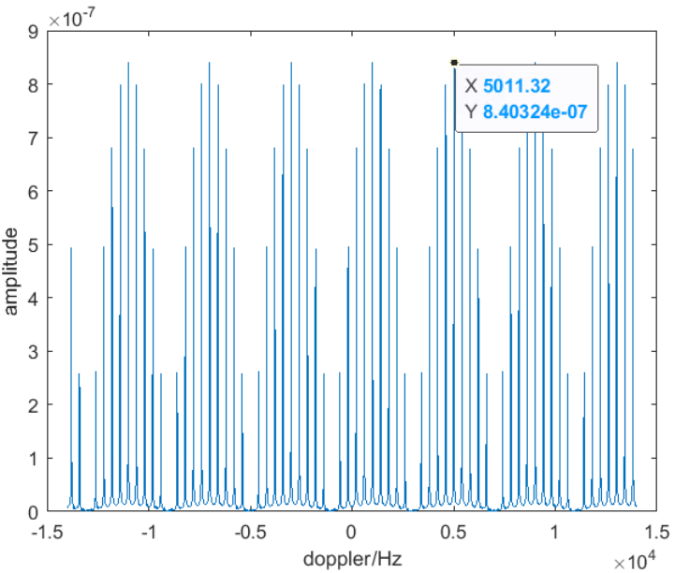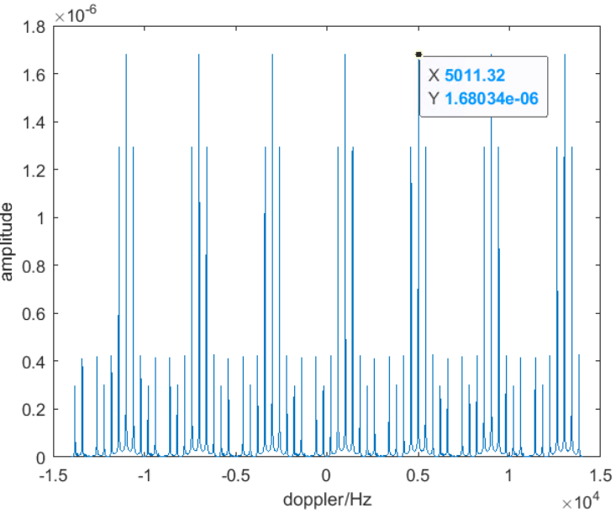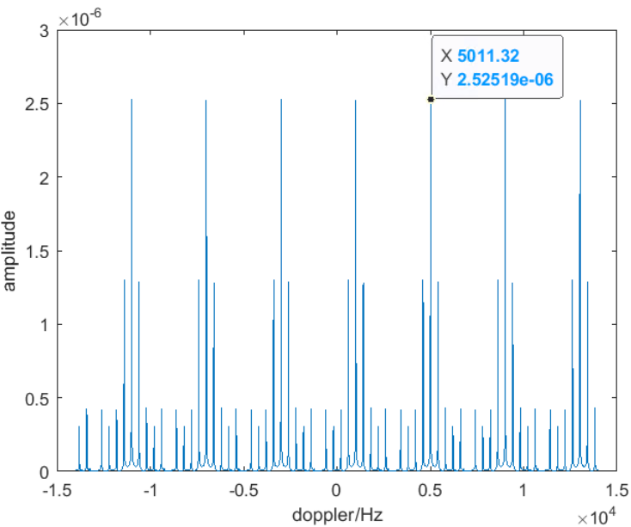
Regular-20% Regular-40% Regular-60%
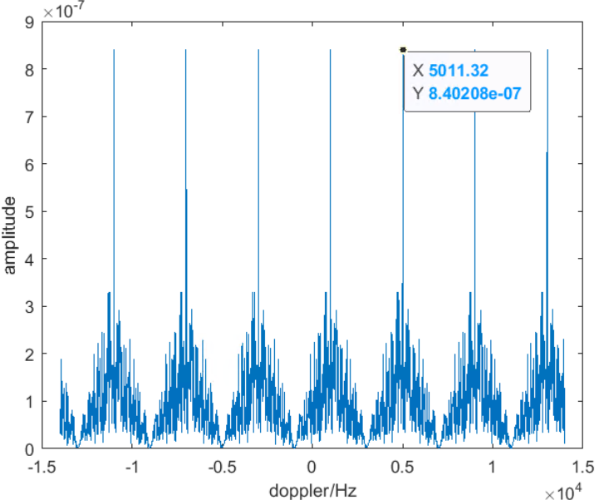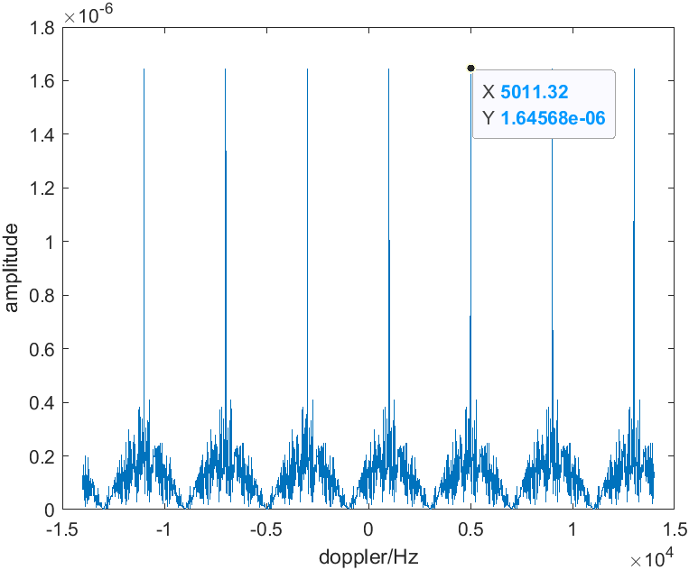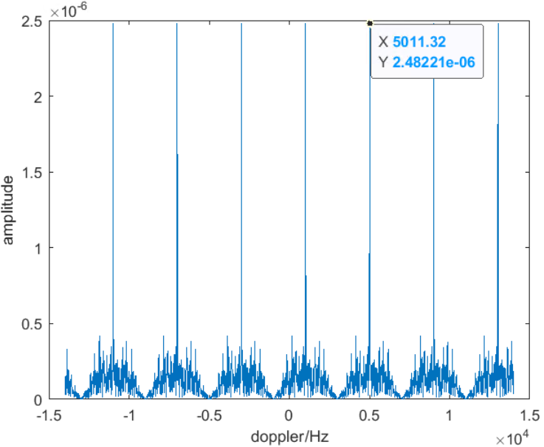
Random-20% Random-40% Random-60%
Figure 1 Doppler detection based on intra-slot symbol pattern {0,7}
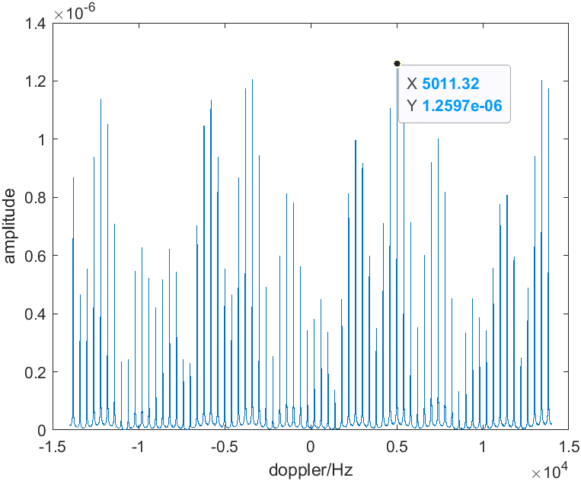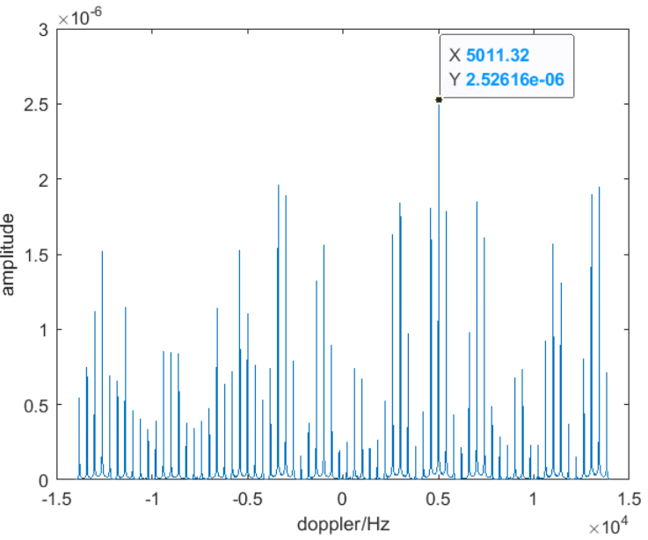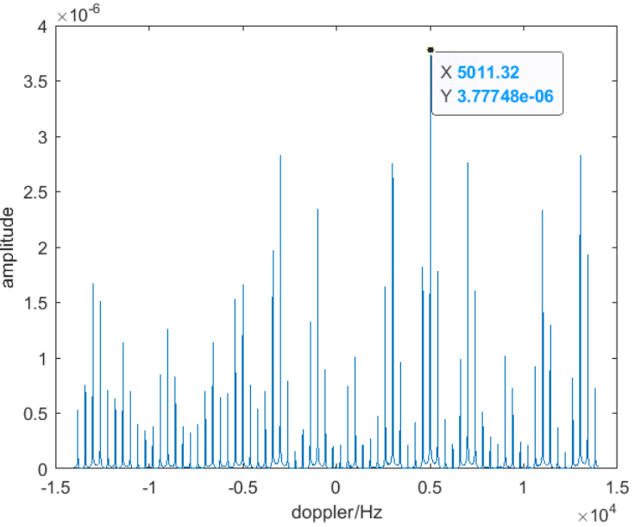
Regular-20% Regular-40% Regular-60%
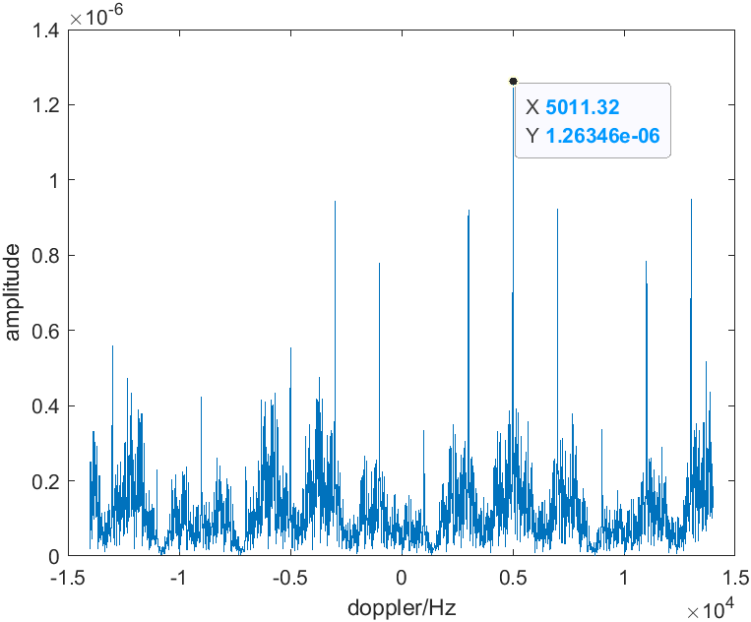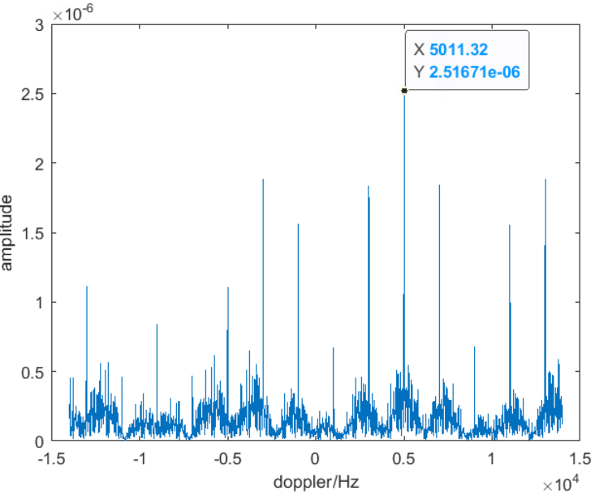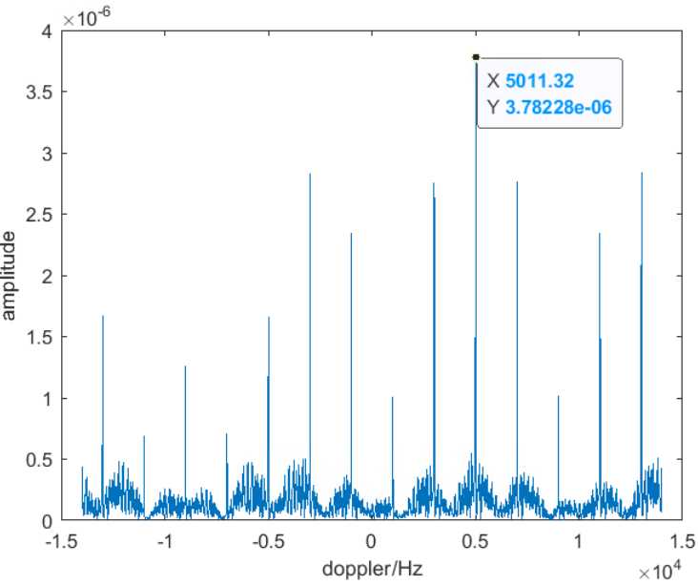
Random-20% Random-40% Random-60%
Figure 2 Doppler detection based on intra-slot symbol pattern {0,3,13}
Although there could be other mathematic methods to solve the optimization problem in equation (2), we still use the DFT algorithm to search for the best $f_{p}$ where the DFT size is the number of symbols in a CPI, i.e., 14*120=1680. In the comparison, the target is assumed to move at a 550km/hr speed, which gives a Doppler shift equal to$f_{d}= \frac{2vf_{c}}{c}≈5 kHz$. The DFT outputs for the comparisons are shown in Figure 1 for pattern A and Figure 2 for pattern B.
It can be seen from Figure 1 and Figure 2 that,
- The Doppler ambiguity occurs for pattern A with multiple equally-strong peaks in Doppler spectrum as shown in Figure 1, but does not occur for pattern B in Figure 2 which gives one single strongest peak in the Doppler spectrum.
- Figure 1 shows an equally strong peak closer to 0 within (0,5kHz) range. This fake peak means that with pattern A, a target moving at 550km/h and actually generating a 5kHz Doppler shift would be observed being moving at a much slower speed that corresponds to a Doppler shift much lower than 5kHz. If the DFT size for pattern A is changed to 2*120=240, this fake peak would be the only peak observed in the Doppler spectrum, and then a “too fast to be legal” play-trick happens. Reversely, if the fake peak closer to 0 is a true peak corresponding to a target indeed moving at a low speed, the pattern A may make the detection algorithm to falsely detect a target moving at 550km/h.
- Within each figure, the performance of the regular-slot pattern and random-slot pattern is clearly presented. Compared to the regular-slot pattern, the random-slot pattern exhibits fewer high-amplitude clutter components and more distinct true-value peaks, which benefits target detection.
In our view, the non-uniform pattern can be a general approach to reduce the sensing RS overhead, and to maintain a maximum unambiguous Doppler range similar to that of the uniform signal design, regardless of the signal interval.
Proposal 4: RAN1 to study the symbol allocation pattern satisfying $gcd\left(\left\{m_{i}-m_{0}\right\}\right)=1$ to maximize the unambiguous Doppler range, where $m_{i}$ is $i$-th sensing RS symbol index (counted beyond slot boundary) within a CPI.
- As a simple starting point, consider $gcd\left(\left\{m_{i}-m_{0}\right\}\right)=1$ for intra-slot only, where $m_{i}$ is $i$-th sensing RS symbol index within a slot, and together with a slot-level (pseudo-)random pattern within the CPI for the slots containing the sensing RS.
Detection of delay
For delay measurement in bi-static mode, the absolute propagation delay along the target path can no longer be directly observed as in mono-static mode. Instead, the measurable quantity is the delay difference relative to the direct path, such as delay corresponding to (a+b)−c illustrated in Figure 1. Such a differential measurement is useful for target positioning only if the propagation path from the STX directly to the SRX (i.e., line c) is a LOS path. If LOS is not guaranteed, the line c becomes a first-arrival NLOS path. Then a RTT-alike timing measurement is required to obtain the delay of the direct path explicitly to give absolute delay corresponding to (a+b) in Figure 1, which works regardless whether the path c is LOS or NLOS. Thereby, there exists two alternatives for delay measurement and report.
- Alt-1: measure/report absolute delay of STX-ST-SRX, i.e., (a+b)
  - Alt-1 does not require the direct path STX-SRX to be LOS, but may have to measure absolute delay on the direct path STX-SRX.
- Alt-2: measure/report delay difference between STX-ST-SRX and STX-SRX, i.e., (a+b)-c
  - Alt-2 requires the direct path STX-SRX to be LOS.
Figure 1: Illustration of bi-static sensing mode
Proposal 5: Study the following two alternatives for delay measurement in bi-static sensing.
- Alt-1: The delay measurement applied to the target positioning is the absolute delay on target path STX-ST-SRX.
- Alt-2: The delay measurement applied to the target positioning is the delay difference between target path STX-ST-SRX and the first arrival path STX-SRX that is assumed in LOS condition.
Detection of angle
The angle detection in bi-static sensing is quite different from that in 5GR mono-static sensing, especially when the SRX is a UE. There are at least two challenges for angle detection in TRP-UE bi-static sensing.
- The antenna element array panel is on the TRP side, and UE as a SRX is not equipped with an advanced antenna panel. Therefore, the angle detection needs to aim at STX(TRP)-to-ST direction, instead of SRX(UE)-to-ST direction, while the angle detection measurement has to be done on UE (SRX) side.
- It can be hardly assumed in both standard and practice that the hardware information of TRP antenna panel, such as dimension/orientation, can be accessed by a UE.
We try to address these two challenges in order to make TRP-to-UE bi-static sensing more feasible in 6GR.
Figure 3 Measurements at SRX to determine STX-to-ST direction
Assume an $S_{H}×S_{V}$ antenna element array panel is on STX side for a TRP-UE bi-static sensing as shown in Figure 3, where
- $d_{p,s}^{STX-ST}$ is the propagation distance on p-th path between STX antenna element s and the ST.
- ${\overset{⃑}{d}}_{s}$ is the position of antenna element s in relative to the element s=0 on the antenna element array panel. It can be translated as ${\overset{⃑}{d}}_{s}=i_{H}∙d_{H}∙{\overset{⃑}{e}}_{H}+i_{V}∙d_{V}∙{\overset{⃑}{e}}_{V}$, where <${\overset{⃑}{e}}_{H}$,${\overset{⃑}{e}}_{V}$> are the unit vectors representing directions in GCS for the horizontal edge and vertical edge, respectively, of the antenna panel, <$d_{H}$,$d_{V}$> are the column spacing and row spacing respectively of the element panel. $0≤i_{H}≤S_{H}-1$ and $0≤i_{V}≤S_{V}-1$ are respectively the column index and row index of an antenna element.
- ${\overset{⃑}{e}}_{p}$ is the unit vector aligning to the p-th propagation path direction from STX to ST in a GCS.
Then the term $\frac{d_{p,u,s}}{λ_{0}}$ in (1) is equivalent to
$$\frac{d_{p,u,s}}{λ_{0}}=\frac{1}{λ_{0}}\left[d_{p,u,s=0}+\left(d_{p,u,s}-d_{p,u,s=0}\right)\right] \\ =\frac{1}{λ_{0}}\left[d_{p,u,s=0}+\left(d_{p,s}^{STX-ST}-d_{p,s=0}^{STX-ST}\right)\right] \\ =\frac{1}{λ_{0}}\left[d_{p,u,s=0}-〈{\overset{⃑}{d}}_{s}∙{\overset{⃑}{e}}_{p}〉\right] \\ =\frac{1}{λ_{0}}\left[d_{p,u,s=0}-\left(i_{H}∙d_{H}∙〈{\overset{⃑}{e}}_{H}∙{\overset{⃑}{e}}_{p}〉+i_{V}∙d_{V}∙〈{\overset{⃑}{e}}_{V}∙{\overset{⃑}{e}}_{p}〉\right)\right] \\ =\frac{d_{p,u,s=0}}{λ_{0}}-\left(i_{H}∙\frac{d_{H}}{λ_{0}}∙\cos{α_{H,p}}+i_{V}∙\frac{d_{V}}{λ_{0}}∙\cos{α_{V,p}}\right)$$
(4)
where $〈\overset{⃑}{x}∙\overset{⃑}{y}〉$ is a dot product of two vectors $\overset{⃑}{x}$ and $\overset{⃑}{y}$ satisfying $〈\overset{⃑}{x}∙\overset{⃑}{y}〉=\left|\overset{⃑}{x}\right|∙\left|\overset{⃑}{y}\right|∙\cos{θ}$, where $θ$ is the angle between $\overset{⃑}{x}$ and $\overset{⃑}{y}$. $\cos{α_{H,p}}$ is the angle between ${\overset{⃑}{e}}_{p}$ and ${\overset{⃑}{e}}_{H}$, and $\cos{α_{V,p}}$ is the angle between ${\overset{⃑}{e}}_{p}$ and ${\overset{⃑}{e}}_{V}$. Mathematically, the STX-to-ST direction ${\overset{⃑}{e}}_{p}$ in GCS can be determined to satisfy:
$\left\{\begin{matrix}{\overset{⃑}{e}}_{H}^{T}∙{\overset{⃑}{e}}_{p}=\cos{α_{H,p}} \\ {\overset{⃑}{e}}_{V}^{T}∙{\overset{⃑}{e}}_{p}=\cos{α_{V,p}}\end{matrix}\right.$ subject to $\left|{\overset{⃑}{e}}_{p}\right|=1$
where $α_{H,p}$ and $α_{V,p}$ come from the measurements with the knowledge of <${\overset{⃑}{e}}_{H}$,${\overset{⃑}{e}}_{V}$> and <$d_{H}$,$d_{V}$>.
In 5G ISAC where $i_{H}∙d_{H}∙\cos{α_{H,p}}$ and $i_{V}∙d_{V}∙\cos{α_{V,p}}$ are individually measurable at mono-static TRP, the TRP measures and reports a pair of angles relative to horizontal plain and vertical plain in GCS to determine the SRX-to-ST direction, which is certainly feasible given the TRP knows <${\overset{⃑}{e}}_{H}$,${\overset{⃑}{e}}_{V}$> and <$d_{H}$,$d_{V}$> of its own panel.
For bi-static sensing, we assume two cases:
- Case-1: The SRX knows <${\overset{⃑}{e}}_{H}$,${\overset{⃑}{e}}_{V}$> and <$d_{H}$,$d_{V}$> of the STX panel.
- Case-2: The SRX does not know any of <${\overset{⃑}{e}}_{H}$,${\overset{⃑}{e}}_{V}$> and <$d_{H}$,$d_{V}$> of the STX panel.
For Case-1, the SRX may measure and report a pair of angles, similar to Level-C report in 5G ISAC. It was discussed in 5G ISAC that, depending on value of $\frac{d_{H}}{λ_{0}}$ and $\frac{d_{V}}{λ_{0}}$, an angle ambiguity issue can occur which cannot be solved locally by the TRP or even gNB. Therefore, one solution is to report such angle ambiguity to SenF.
For Case-2, instead of measuring a pair of angles, the SRX can measure $\frac{d_{H}}{λ_{0}}∙\cos{α_{H,p}}$ in (4) as a whole and $\frac{d_{V}}{λ_{0}}∙\cos{α_{V,p}}$ as a whole, and then report these two measurements to SenF that knows <${\overset{⃑}{e}}_{H}$,${\overset{⃑}{e}}_{V}$> and <$d_{H}$,$d_{V}$>. In such a way, the SRX avoids the knowledge of <${\overset{⃑}{e}}_{H}$,${\overset{⃑}{e}}_{V}$> and <$d_{H}$,$d_{V}$>, which are all contained in the measurements and reports, and can shift the responsibility of angle ambiguity handling to SenF.
Proposal 6: RAN1 to study the following two cases in angle measurements.
- Case-1: A SRX knows element spacing and panel orientation information of the STX antenna element array panel.
  - The SRX measures a pair of angles for determination of STX-to-ST direction.
  - The SRX knows whether the measured angle is subject to angle ambiguity.
- Case-2: A SRX does not know any of element spacing and panel orientation information of the STX antenna element array panel.
  - The SRX measures a pair of distances in unit of wavelength, $\frac{d_{H}}{λ_{0}}∙〈{\overset{⃑}{e}}_{H}∙{\overset{⃑}{e}}_{p}〉$ and $\frac{d_{V}}{λ_{0}}∙〈{\overset{⃑}{e}}_{V}∙{\overset{⃑}{e}}_{p}〉$, and reports the pair of measurements to SenF which can access STX panel orientation information <${\overset{⃑}{e}}_{H}$,${\overset{⃑}{e}}_{V}$> and STX antenna element spacing information <$d_{H}$,$d_{V}$> and determine the STX-to-ST direction.
  - The SRX does not know whether the above pair of measurements can lead to angle ambiguity.
Denote $d_{H,p}^{'}=\frac{d_{H}∙\cos{α_{H,p}}}{λ_{0}}=\frac{d_{H}}{λ_{0}}∙〈{\overset{⃑}{e}}_{H}∙{\overset{⃑}{e}}_{p}〉$ and $d_{V,p}^{'}=\frac{d_{V}∙\cos{α_{V,p}}}{λ_{0}}=\frac{d_{V}}{λ_{0}}∙〈{\overset{⃑}{e}}_{V}∙{\overset{⃑}{e}}_{p}〉$. Next, we discuss how to let SRX to measure $d_{H,p}^{'}$ and $d_{V,p}^{'}$, as in Case-2, with antenna element array on the STX side. The measurements in Case-1 shares the same principle.
Bring equation (4) into (1) and transform equation (1) from time-delay domain to time-frequency domain in (5).
$R_{u}\left(m,k\right)=\sum_{p}{{α'}_{p,u}\left(\sum_{i_{H}=0}^{S_{H}-1}{\sum_{i_{V}=0}^{S_{V}-1}{e^{-j2π\left(i_{H}∙d_{H,p}^{'}+i_{V}∙d_{V,p}^{'}\right)}C_{t}\left(m,p\right)C_{f}\left(k,p\right)S\left(m,k\right)}}\right)}+n\left(m,k\right)$ (5)
where $C_{t}\left(m,p\right)=exp\left(j2π\int_{t_{0}}^{mT_{sym}}{f_{p}\left(\tilde{t}\right)d\tilde{t}}\right)$ and $C_{f}\left(k,p\right)=exp\left(-j2πk∙∆f∙τ_{p}\right)$. Then $d_{H,p}^{'}$ can be measured via a $S_{H}$-point DFT if $e^{-j2π\left(i_{H}∙d_{H,p}^{'}\right)}$ for $0≤i_{H}≤S_{H}-1$ are individually measurable; similarly, $d_{V,p}^{'}$ can be measured via a $S_{V}$-point DFT if $e^{-j2π\left(i_{V}∙d_{V,p}^{'}\right)}$ for $0≤i_{V}≤S_{V}-1$ are individually measurable. In order to retrieve $e^{-j2π\left(i_{H}∙d_{H,p}^{'}\right)}$ and $e^{-j2π\left(i_{V}∙d_{V,p}^{'}\right)}$ individually from $R_{u}\left(m,k\right)$, the sensing signal $S\left(m,k\right)$ should be differentiable from each other (better to be orthogonal to each other) over different combinations of antenna element indices <$i_{H}$,$i_{V}$>. In other words, $S\left(m,k\right)$ in (5) needs to be replaced by $S_{i_{H},i_{V}}\left(m,k\right)$. The multiplexing among $S_{i_{H},i_{V}}\left(m,k\right)$ for different <$i_{H}$,$i_{V}$> combinations can be time-division, frequency-division and/or sequence-division.
It should be noted that, although the STX-to-ST direction impacts the amplitude terms ${α'}_{p,u}$ as well, such impact remains constant for a given STX-to-ST direction and results in a common coefficient shared by all terms of $e^{-j2π\left(i_{H}∙d_{H,p}^{'}\right)}$ and $e^{-j2π\left(i_{V}∙d_{V,p}^{'}\right)}$, and therefore can be irrelevant.
Proposal 7: RAN1 to study the measurements performed by SRX for detection of STX-to-ST direction with the antenna element array on the STX side, by making the sensing reference signals transmitted over different antenna elements/ports on the STX panel to be differentiable/orthogonal from each other.

Sensing measurement reports
5G-A ISAC has supported multi-level measurement reporting, which fully demonstrates that sensing measurement results can be obtained at different stages in the entire signal processing.
- Level B: profiles of Doppler/delay/angle
- Level C: Doppler/delay/angle per point based on detection
- Level D: position and velocity per target
The same 5G measurement report framework can be considered as a good reference for 6G measurement report study. In fact, we see the benefits to inherit the multi-level reporting from 5G to 6G, given a TRP and a UE bear different reporting throughput capabilities. As a measuring SRX, a UE has to send the report over a wireless channel, so the reporting data volume cannot be high – only Level C and Level D fit the reporting by UE. On the other hand, a TRP can tolerate a heavy reporting overhead on a wired link and thus support the delivery of more non-processed information to a centralized processing node like SenF, which contributes to superior sensing performance. All levels across B/C/D are applicable to TRP/aNB reporting.
Proposal 8: For UE-side sensing measurements, the following measurement report levels can be considered.
- Level C: per-point measurements, including Doppler/delay/angle or their equivalence per detected point.
- Level D: per-target measurements, including position/velocity per detected target.
A target detection is typically performed based on a peak value of a point or path, as well as its ratio relative to noise and surrounding clutters. The sharper the peak and the higher this ratio, the more likely the corresponding point or path represents a valid target. In data fusion implementations, this ratio metric can also serve as a weighting factor to produce the final accurate detection result. Thereby it is preferred to consider the metric related to power and/or power-to-noise ratio as the measurements to reflect sensing quality.
Proposal 9: RAN1 to study the power-related metrics contained in the measurement report, e.g., RSRP, sensing SINR.
To decide the reported signaling in measurement report mechanism, e.g., L1, L2 and higher layer signaling, several factors should be taken into account, including payload size, reporting latency and privacy. In terms of payload size, as specification allows, the maximum payload of L1 signaling is generally on the order of several kilobits, and that of L2 signaling is around several hundred kilobits, while higher-layer signaling supports a further larger payload capacity. As for reporting latency, due to differences in aggregation and processing procedures, the latency increases in the order of L1, L2, and higher-layer signaling. Additionally, L1 and L2 signaling are non-transparent to the aNB, whereas higher-layer signaling can be made more friendly to privacy. Given the diverse requirements of sensing use cases in terms of sensing sensitivity, reporting latency and data volume, the measurement report signaling can be selected in an adaptive manner. Furthermore, methods for report overhead reduction deserve further investigation, particularly for measurement report signaling with limited payload size.
Proposal 10: The sensing measurement report signaling should accommodate various sensing use cases.
- Report overhead reduction method needs to be further studied, especially for the reported signaling with limited payload size.

Interaction between sensing and communication

Sensing signal resource allocation interpretation
A signal transmitted in a communication air-interface needs to be categorized as either a downlink signal or an uplink signal. Meanwhile, a sensing signal transmitted by a TRP or a UE can be received and measured by both of a different TRP and a different UE in a multi-static sensing procedure, but it should not be categorized as the downlink signal and the uplink signal at the same time. Therefore, the categorization of a sensing signal to DL signal or UL signal should be decided from transmitter perspective, not from receiver perspective.
Proposal 11: In 6G ISAC study,
- A sensing signal transmitted by a network entity (e.g., TRP) is categorized as a downlink signal.
  - Particularly, sensing signals in TRP-TRP bi-static mode and TRP mono-static mode are treated as downlink signals.
- A sensing signal transmitted by a terminal entity (e.g., UE) is categorized as an uplink signal.
  - Particularly, sensing signals in UE-UE bi-static mode and UE mono-static mode are treated as uplink signals.
When a sensing signal is transmitted from a STX, there can be two alternatives for a SRX (either TRP or UE) to interpret the resources allocated to the sensing signal.
- Alternative 1: The sensing signal resources are allocated to a frequency layer instead of a resource-grid of a particular cell. This is more like a resource allocation in 5G for the positioning-purposed PRS, and is only applicable to the STX as a TRP.
- Alternative 2: The sensing signal resources are allocated within the resource grid of a cell. This is more like a resource allocation in 5G for the PDC-purposed PRS, CSI-RS and etc., and is applicable to both STX as a TRP and STX as a UE.
Proposal 12: RAN1 to study the following alternatives for the resource allocation of a sensing signal.
- Alt-1 (applicable to STX as a TRP): The sensing signal resources are allocated to a cell-independent frequency layer instead of a resource-grid of a particular cell.
- Alt-2 (applicable to both STX as a TRP and STX as a UE): The sensing signal resources are allocated within the resource grid of a cell.
Although it is too early at this stage to discuss the 6G UE feature on sensing, RAN1 should at least not assume in the 6G study that sensing is a mandatory UE feature.
Proposal 13: RAN1 does not presume in 6G study that sensing is a mandatory UE feature.
If a sensing signal transmitted over the air impacts the resource allocation of a communication signal or channel that should be received by a sensing-incapable UE, a sensing transparent rate-matching should be used on the UE side without requiring the UE to be capable of understanding the sensing signal configurations.
Proposal 14: Any impact by a sensing signal to the resource allocation of a communication signal/channel that is to be received by a sensing-incapable UE should be handled in a sensing-transparent way from the UE perspective.

Sensing signal overheads upon communication
5G ISAC agreed the sensing RS overhead to be calculated as following:
For the evaluation on NR ISAC,
- 3 kinds of resources are defined
- Type 1: resources that are used for sensing signal transmission
- Type 2: part of Type 1 resources that are used for communication purpose
  - Note: it is possible the resource type 2 doesn’t exist
- Type 3: resources that are not used for sensing signal transmission, and cannot be used for communication purpose due to sensing operation
- Both options should be reported for sensing resource ratio
- Option 1: (Type_1 + Type_3) resources over all radio DL and UL resources
- Option 2: (Type_1 - Type_2 + Type_3) resources over all radio DL and UL resources
- Note: if Type 2 resource doesn’t exist, two options are the same
This agreement outlines two types of sensing overheads:
- Type-A (i.e., Type1-Type2 in 5G): The resources allocated to a sensing signal that is not usable for communication purpose.
- Type-B: The resources not allocated to any sensing signal but not usable for communication purpose due to sensing functionality.
In the agenda 10.8.2, the (Type1-Type2) overhead can be simply computed as the resources needed for a sensing-dedicated reference signal, while the Type-3 overhead can be more related to the deployment and interference management, which should be handled in agenda 10.8.1. In addition, it should be clarified whether the overhead is counted on STX side or SRX side.
Proposal 15: RAN1 to consider two types of sensing signal overheads.
- Type-A: The resources allocated to a sensing signal that is not usable for communication purpose.
- Type-B: The resources not allocated to any sensing signal but still not usable for communication purpose due to sensing functionality.
- Type-A overhead is studied in agenda 10.8.2, while the comprehensive impacts over both types of overheads is studied in agenda 10.8.1.
- It should be clarified whether the overheads are counted from STX perspective or SRX perspective.

Collision between sensing and communication
In a 6G ISAC system, communication signals and sensing signals share the same time-frequency resource pool, and such sharing may leave an unavoidable collision between communications and sensing, where a collision can occur in one of following situations:
- A sensing signal and a communication signal/channel compete to each other on a STX side for transmission on the same resources. This usually results in a signal puncturing from receiver point of view.
- A sensing signal and a communication signal/channel compete to each other on a SRX side for reception on the same resources. This usually results in a signal reception overriding from receiver point of view.
- A downlink (or uplink) sensing signal transmitted by a STX falls into a slot where the specification does not allow a SRX to receive.
In our view, the RAN1 study of collision between sensing and communication should strive to answer following questions:
- What the resource granularity is in the collision handling. The granularity can be on RE-level, symbol-level and slot-level etc.
- Whether there should be a collision in which a sensing signal always wins over any communication signal/channel.
  - If yes, the identification of such collision case should be delivered to the corresponding RAN1 agenda for the further study if handling mechanism.
- How to handle the collision case in which a sensing signal is punctured/overridden by communication signal/channel.
The evaluation in section 2.1 shows a proof that an irregular time-domain symbol pattern does not prevent a SRX from measuring the Doppler correctly. This evaluation observation also provides an indication that a collision handling which may result in an irregular sensing RS pattern in time-domain does not necessarily kill the Doppler measurements on SRX side.
Proposal 16: RAN1 to study handling of following collisions between sensing and communication.
- Collision-1: A sensing signal and a communication signal/channel compete to each other on a STX side due to transmission on a same set of resources.
- Collision-2: A sensing signal and a communication signal/channel compete to each other on a SRX side due to reception on a same set of resources.
- Collision-3: A sensing signal transmitted by a STX falls into a set of resources where the specification does not allow a SRX to receive even without competition from a communication signal/channel.
- The study includes the granularities for the set of resources in each type of above collisions, e.g., RE-level vs. symbol-level vs. slot-level.

Power control on the sensing signal
The power control should be studied at least for bi-static sensing where a UE is the STX. From a sensing perspective, it maybe preferred to maintain a constant transmission power by STX within a CPI; however, from a communication perspective, a UE may be required to follow uplink TPC procedure by adjusting its transmission power on a slot basis for the interference management at the receiver side. Especially when the receiver is a network node like TRP or aNB, the ability for a UE to reduce its transmission power on a slot-basis could become essential.
Proposal 17: RAN1 to study power control upon sensing signal transmission in bi-static sensing mode where a UE is in the role of STX.

Conclusions
This contribution concludes with the following proposals.
Proposal 1: Adopt following terminologies/abbreviations for sensing entities in RAN1 discussion of 6G ISAC.
- STX: Sensing transmitter.
- SRX: Sensing receiver.
- ST: Sensing target.
- SenF: Sensing function node on network side.
Proposal 2: RAN1 study of 6G ISAC in AI 10.8.2 does not assume a preclusion of any frequency range.
Proposal 3: The 6GR study of object detection and tracking should focus on the detection of Doppler/delay/angle or their equivalences.
Proposal 4: RAN1 to study the symbol allocation pattern satisfying $gcd\left(\left\{m_{i}-m_{0}\right\}\right)=1$ to maximize the unambiguous Doppler range, where $m_{i}$ is $i$-th sensing RS symbol index (counted beyond slot boundary) within a CPI.
- As a simple starting point, consider $gcd\left(\left\{m_{i}-m_{0}\right\}\right)=1$ for intra-slot only, where $m_{i}$ is $i$-th sensing RS symbol index within a slot, and together with a slot-level (pseudo-)random pattern within the CPI for the slots containing the sensing RS.
Proposal 5: Study the following two alternatives for delay measurement in bi-static sensing.
- Alt-1: The delay measurement applied to the target positioning is the absolute delay on target path STX-ST-SRX.
- Alt-2: The delay measurement applied to the target positioning is the delay difference between target path STX-ST-SRX and the first arrival path STX-SRX that is assumed in LOS condition.
Proposal 6: RAN1 to study the following two cases in angle measurements.
- Case-1: A SRX knows element spacing and panel orientation information of the STX antenna element array panel.
  - The SRX measures a pair of angles for determination of STX-to-ST direction.
  - The SRX knows whether the measured angle is subject to angle ambiguity.
- Case-2: A SRX does not know any of element spacing and panel orientation information of the STX antenna element array panel.
  - The SRX measures a pair of distances in unit of wavelength, $\frac{d_{H}}{λ_{0}}∙〈{\overset{⃑}{e}}_{H}∙{\overset{⃑}{e}}_{p}〉$ and $\frac{d_{V}}{λ_{0}}∙〈{\overset{⃑}{e}}_{V}∙{\overset{⃑}{e}}_{p}〉$, and reports the pair of measurements to SenF which can access STX panel orientation information <${\overset{⃑}{e}}_{H}$,${\overset{⃑}{e}}_{V}$> and STX antenna element spacing information <$d_{H}$,$d_{V}$> and determine the STX-to-ST direction.
  - The SRX does not know whether the above pair of measurements can lead to angle ambiguity.
Proposal 7: RAN1 to study the measurements performed by SRX for detection of STX-to-ST direction with the antenna element array on the STX side, by making the sensing reference signals transmitted over different antenna elements/ports on the STX panel to be differentiable/orthogonal from each other.
Proposal 8: For UE-side sensing measurements, the following measurement report levels can be considered.
- Level C: per-point measurements, including Doppler/delay/angle or their equivalence per detected point.
- Level D: per-target measurements, including position/velocity per detected target.
Proposal 9: RAN1 to study the power-related metrics contained in the measurement report, e.g., RSRP, sensing SINR.
Proposal 10: The sensing measurement report signaling should accommodate various sensing use cases.
- Report overhead reduction method needs to be further studied, especially for the reported signaling with limited payload size.
Proposal 11: In 6G ISAC study,
- A sensing signal transmitted by a network entity (e.g., TRP) is categorized as a downlink signal.
  - Particularly, sensing signals in TRP-TRP bi-static mode and TRP mono-static mode are treated as downlink signals.
- A sensing signal transmitted by a terminal entity (e.g., UE) is categorized as an uplink signal.
  - Particularly, sensing signals in UE-UE bi-static mode and UE mono-static mode are treated as uplink signals.
Proposal 12: RAN1 to study the following alternatives for the resource allocation of a sensing signal.
- Alt-1 (applicable to STX as a TRP): The sensing signal resources are allocated to a cell-independent frequency layer instead of a resource-grid of a particular cell.
- Alt-2 (applicable to both STX as a TRP and STX as a UE): The sensing signal resources are allocated within the resource grid of a cell.
Proposal 13: RAN1 does not presume in 6G study that sensing is a mandatory UE feature.
Proposal 14: Any impact by a sensing signal to the resource allocation of a communication signal/channel that is to be received by a sensing-incapable UE should be handled in a sensing-transparent way from the UE perspective.
Proposal 15: RAN1 to consider two types of sensing signal overheads.
- Type-A: The resources allocated to a sensing signal that is not usable for communication purpose.
- Type-B: The resources not allocated to any sensing signal but still not usable for communication purpose due to sensing functionality.
- Type-A overhead is studied in agenda 10.8.2, while the comprehensive impacts over both types of overheads is studied in agenda 10.8.1.
- It should be clarified whether the overheads are counted from STX perspective or SRX perspective.
Proposal 16: RAN1 to study handling of following collisions between sensing and communication.
- Collision-1: A sensing signal and a communication signal/channel compete to each other on a STX side due to transmission on a same set of resources.
- Collision-2: A sensing signal and a communication signal/channel compete to each other on a SRX side due to reception on a same set of resources.
- Collision-3: A sensing signal transmitted by a STX falls into a set of resources where the specification does not allow a SRX to receive even without competition from a communication signal/channel.
- The study includes the granularities for the set of resources in each type of above collisions, e.g., RE-level vs. symbol-level vs. slot-level.
Proposal 17: RAN1 to study power control upon sensing signal transmission in bi-static sensing mode where a UE is in the role of STX.

References
- RAN1#124bis Chairman notes.

